**Telegram Bot Integration**

Telegram API Token Creation:

1. Open telegram app
2. Search for BotFather having a blue tick
3. Send the “/start” command to BotFather

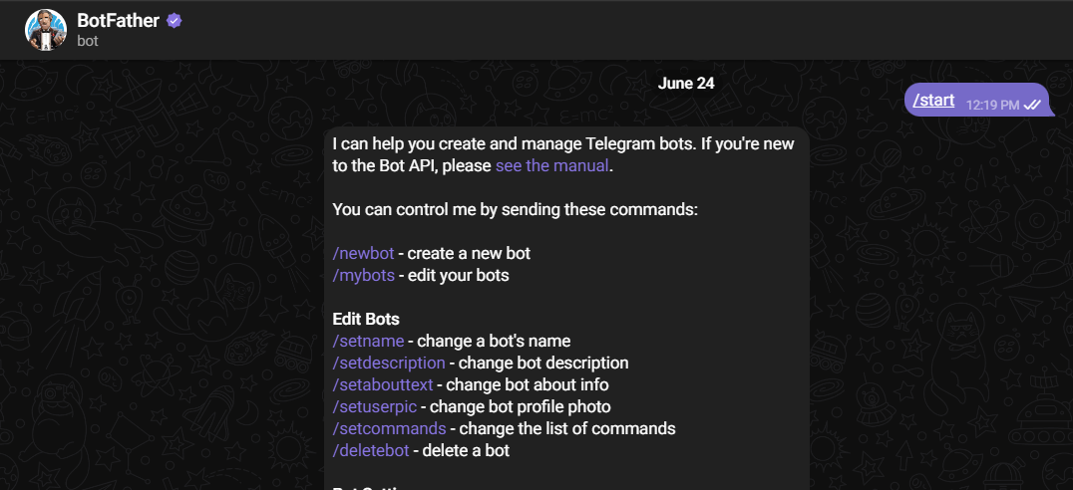

1. Create a new bot using “/newbot” command
2. Choose a name for your bot
3. Choose a username for your bot (It must end with ‘bot’ keyword)

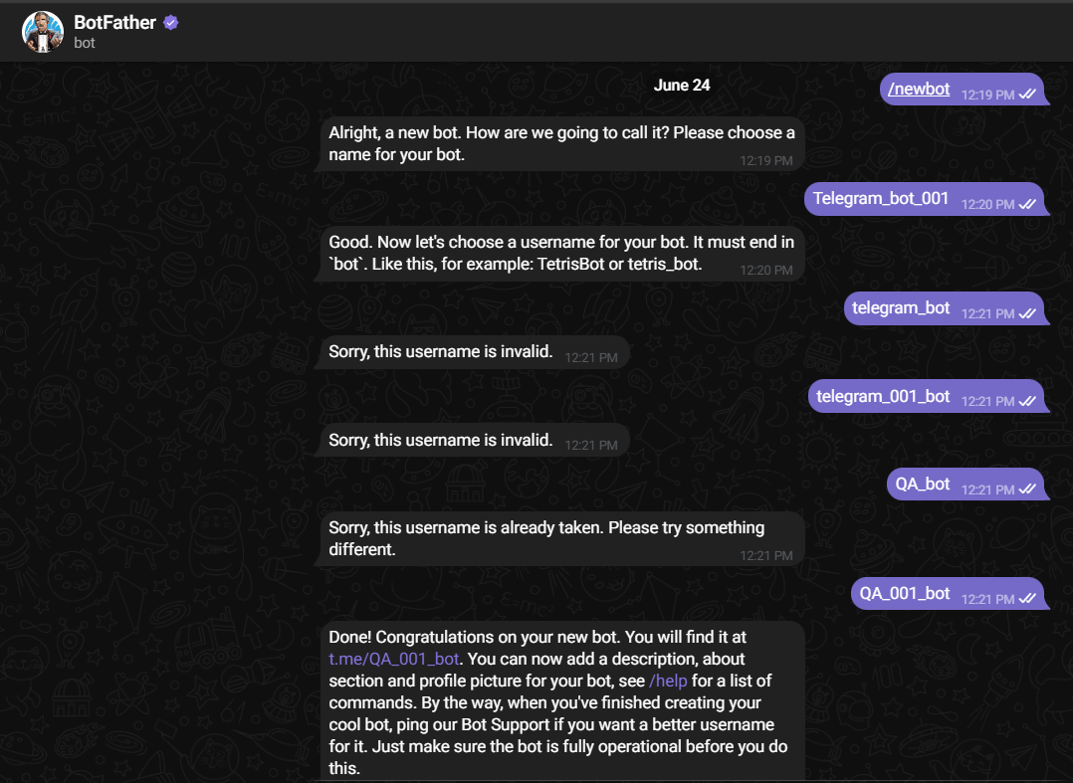

1. Send the “/mybots” command for getting the token of created bot

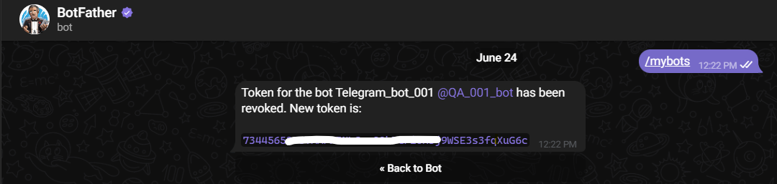

1. Use this telegram Api token in your chatbot code

Two ways to integrate the chatbot with Telegram:

* Create a chatbot directly using telegram API token:

Make a config file that contains all secret API keys:

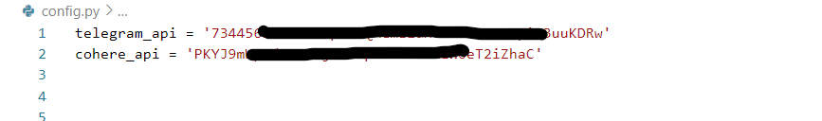

Installations for the code:

pip install telebot langchain-cohere langchain

Main file: [telegram_bot_integration/telegrambot.py at main · bizAnurag1/telegram_bot_integration (github.com)](https://github.com/bizAnurag1/telegram_bot_integration/blob/main/telegrambot.py)

* Create a fast-Api backend and use the URL with payload in telegram API code:

Make a config file that contains all secret API keys:



Installations for the backend:

pip install fastapi pydantic langchain-cohere langchain

backend file: [telegram_bot_integration/backend.py at main · bizAnurag1/telegram_bot_integration (github.com)](https://github.com/bizAnurag1/telegram_bot_integration/blob/main/backend.py)

Installations for the telegram API code:

pip install python-telegram-bot requests

Telegram bot file: [telegram_bot_integration/telegram_bot.py at main · bizAnurag1/telegram_bot_integration (github.com)](https://github.com/bizAnurag1/telegram_bot_integration/blob/main/telegram_bot.py)

Thank You!!